Chapter 15, Solution 48.

- Let 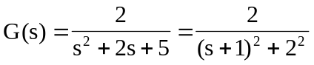

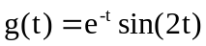

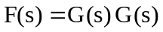

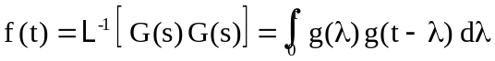

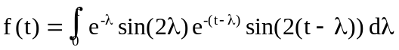

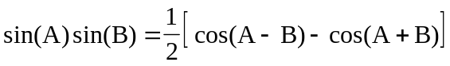

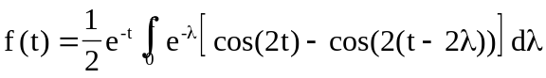
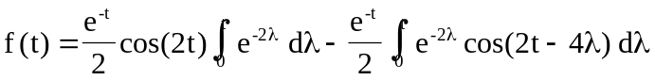
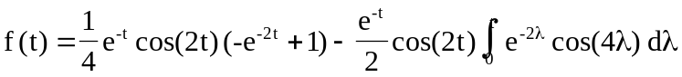
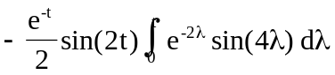

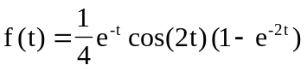
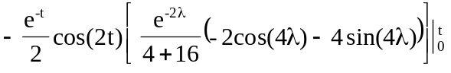
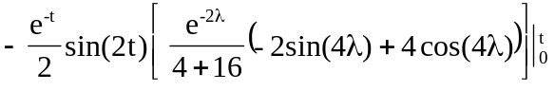

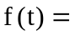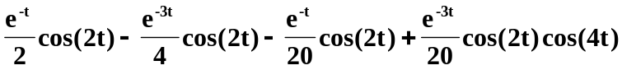
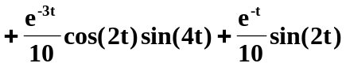
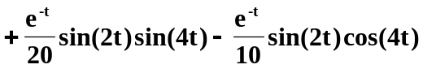

- Let  